WORKSHEET
A. Identify the incorrect Preposition and rewrite the sentences with correct Preposition:
1. She is standing in the door.
2. The plane flew directly on the city.
3. I will meet you on the bus stop.
4. He sat under me in the theatre.
5. Hang the painting under the wall light.
6. Put the keys beside your pocket so you don't lose them.
7. Our house is under the park, just a two-minute walk away.

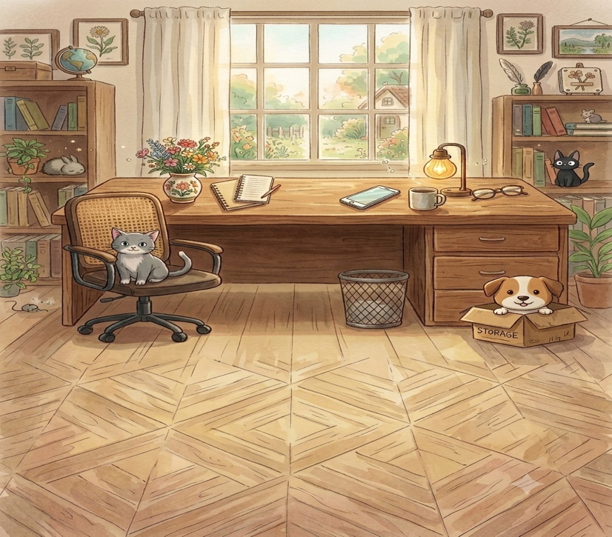
B. Look at the picture given, and choose the correct preposition:

It was a quiet afternoon in the cozy study room. A cute little cat was resting comfortably (1) __________ (on, under, behind) the rolling chair that was placed in front of a large desk. On top of the wooden desk, a lamp stood (2) __________ (between, beside, under) a cup and a pair of glasses. Nearby, a phone was neatly placed (3) __________ (on, under, in) the desk surface. If you looked closely near the drawers, a waste bin was sitting right (4) __________ (under, above, on) the desk, tucked near the centre. Meanwhile, a small puppy peeked out cheerfully from (5) __________ (inside, over, on) a cardboard box resting on the floor. Looking further across the room, a small globe could be seen sitting safely (6) __________ (on, under, behind) the top of the bookshelf.

The Prepositions in the passage are wrong. Rewrite the prepositions correctly using the format: CORRECT WORD- INCORRECT WORD
Rohan was sitting in the chair under a big table to do his homework. His cat was sleeping under the bed, right on his head. Rohan put his pencil below his notebook. Outside, a colourful bird flew between the sky. There was a big tree on his house, and a tiny puppy was standing above the box in the garden. Rohan shared his sweets between all four of his friends before going to play in top of the slide.

Answers
A. She is standing at the door.
* The plane flew directly over the city.
* I will meet you at the bus stop.
* He sat behind me in the theatre.
* Hang the painting above the wall light.
* Put the keys in your pocket so you don't lose them.
* Our house is near the park, just a two-minute walk away.

B. 1. on (on the rolling chair)
2. beside (beside a cup)
3. on (on the desk surface)
4. under (under the desk)
5. inside (inside a cardboard box)
6. on (on the top of the bookshelf)

C.
Rohan was sitting on the chair at a big table to do his homework. His cat was sleeping on the bed, right near his head. Rohan put his pencil beside his notebook. Outside, a colorful bird flew in the sky. There was a big tree near his house, and a tiny puppy was standing in the box in the garden. Rohan shared his sweets among all four of his friends before going to play on top of the slide.

